**How Can Kids Make Robots at Home**

Nowadays, we see robots appearing in so many areas of day-to-day life. Educators find that getting kids to make their own robots is not only fun but an awesome educational experience. It helps children develop their interests in STEM subjects early in their lives, laying a foundation for future study. But how to make a robot at home?

Making robots at home doesn’t have to be very complex or hard to do. Here are three kinds of simple DIY robots that parents can build alongside their kids.

**1. The “Bristlebot”**

A bristlebot is a simple and tiny robot your kids can build at home using a toothbrush. Cut off the bristle end of the toothbrush and connect a small pre-isolated motor with some coin cell batteries. This little setup is quite easy to make, but the experience of building it is rewarding and fun for kids. Here is a video to teach you to make a bristlebot step by step: <https://vimeo.com/71254728>.

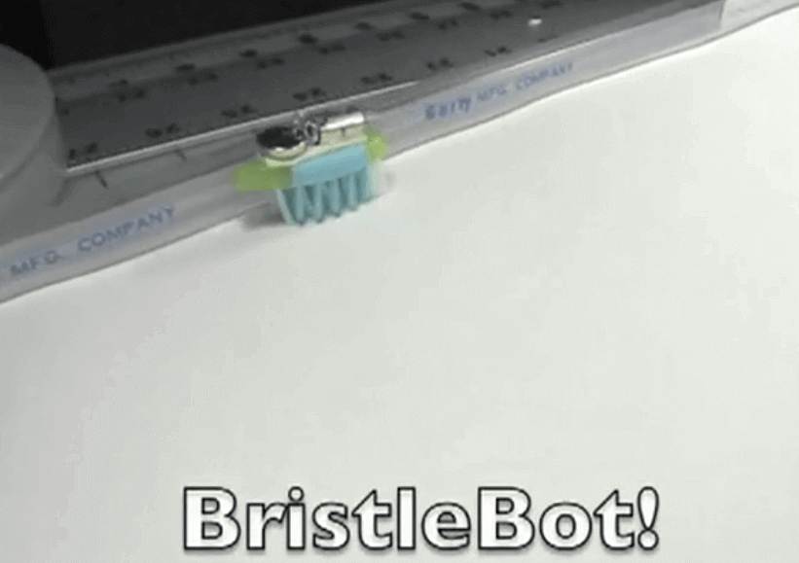

**2. A Rolling Robot**

A rolling robot requires more materials and effort from your kids than a bristlebot does. However, the result is absolutely much more exciting and rewarding. For this project, we suggest parents assist your kids with the process, as certain steps involve handling a drill. We highly recommend the makers to wear safety goggles.

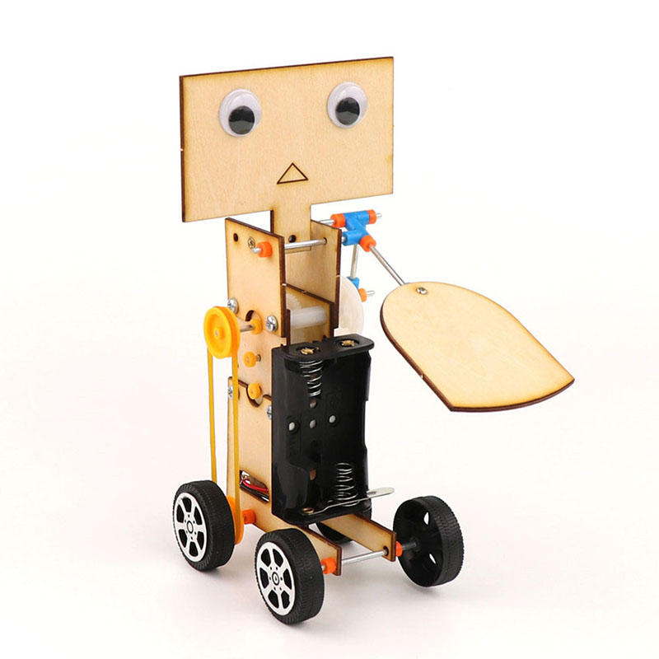

**3. A Rowing-Boat Robot**

Tired of only having robots move on the floor? This rowing-boat robot, which is made out of a DC motor and two batteries, can float and move along on the water. During summer, your kids can build rowing-boat robots with their friends and take their robots outside to the pool. Here is a video to walk you through the process of building this robot: [https://www.instructables.com/id/How-to-make-a-Toy-Rowing-Boat/.](https://www.instructables.com/How-to-make-a-Toy-Rowing-Boat/)

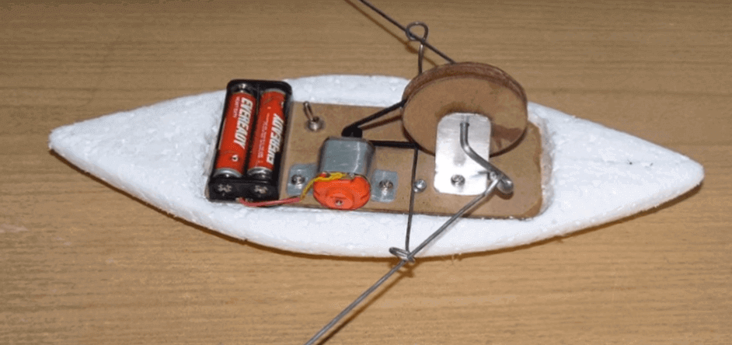

The robots introduced above are family-friendly and easy to make; however, children tend to get bored quickly due to the simple structures and limited challenges of these robots. If parents found that how to make a robot at home doesn’t work, mBot could be a better alternative to these easy DIY robots.

[**4. mBot: a STEM Coding robot**](https://store.makeblock.com/products/mbot-robot-kit)

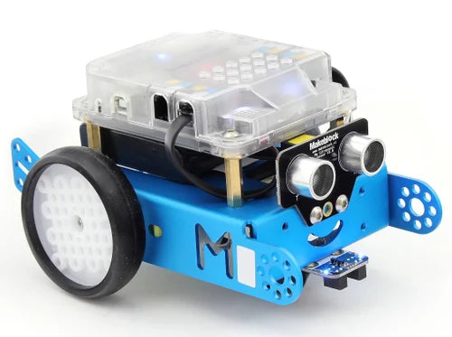

[mBot](https://makeblock.com/products/buy-mbot) is a STEM education robot for beginners. With just a screwdriver, and step-by-step instructions, and a study schedule, children can build a robot from scratch and experience the joys of hands-on creation. [mBot](https://makeblock.com/products/buy-mbot" \t "_self) offers great flexibility when it comes to shapes and is also compatible with LEGO bricks, meaning gameplay can continue to grow over time. In addition, mBot is supported by the [Makeblock App](https://www.makeblock.com/pages/software" \t "_self), a piece of powerful operating software. It enables children to control their mBot at the touch of a button or combine the preset control settings any way they choose.

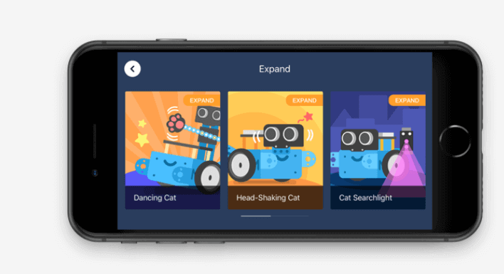

As they go, kids will learn about a variety of robotic machinery and electronic parts, get to grips with the fundamentals of block-based programming, and develop their logical thinking and design skills.

Top of Form

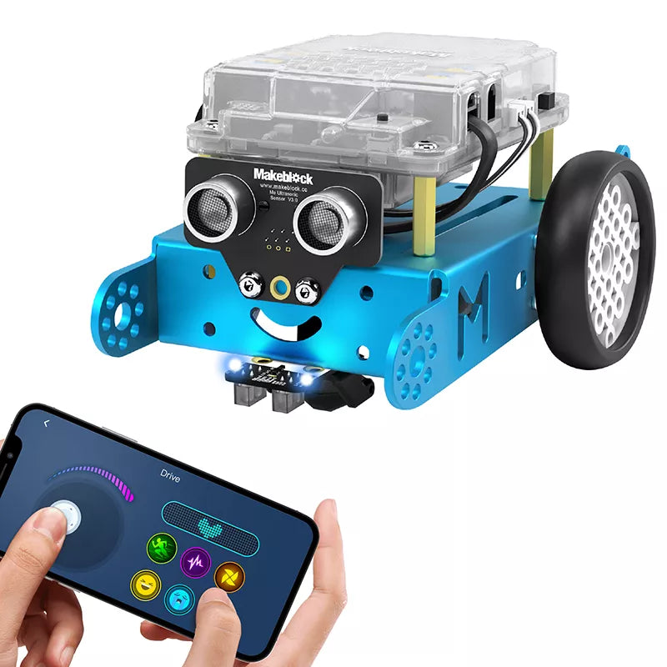

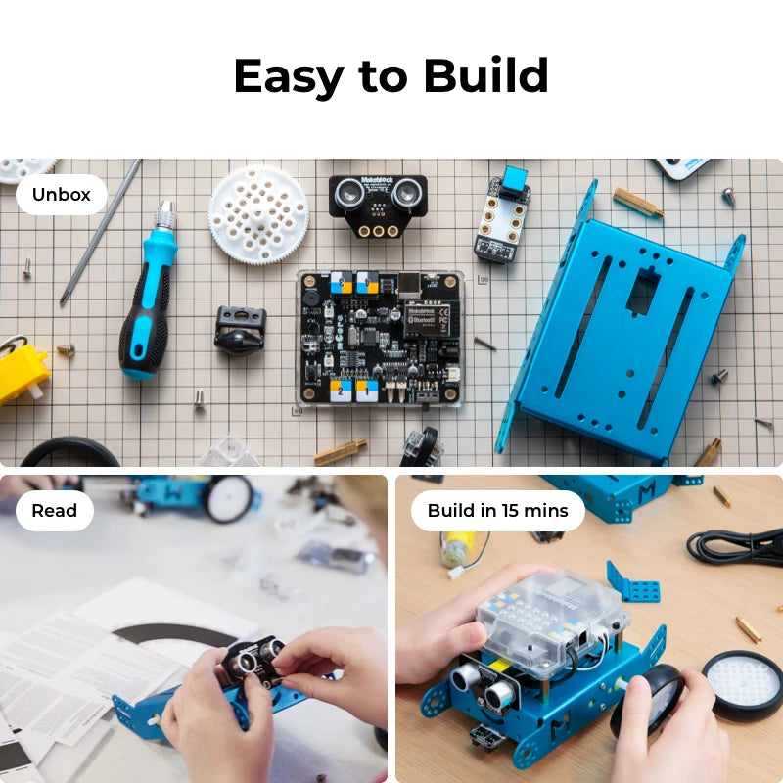

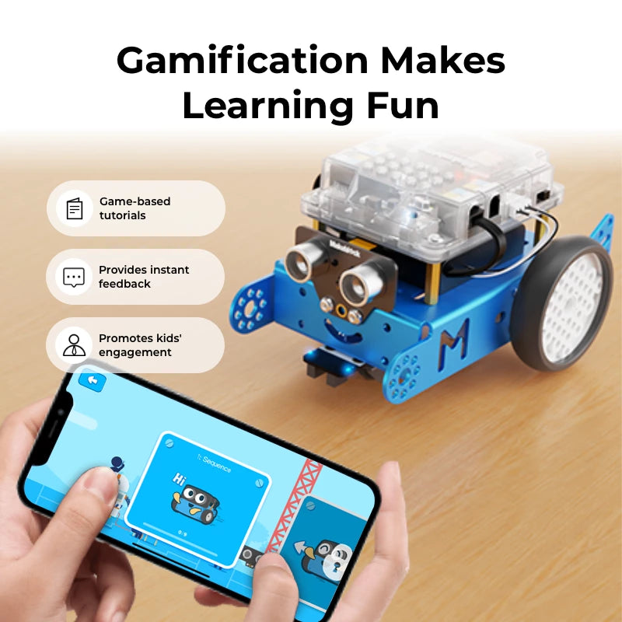

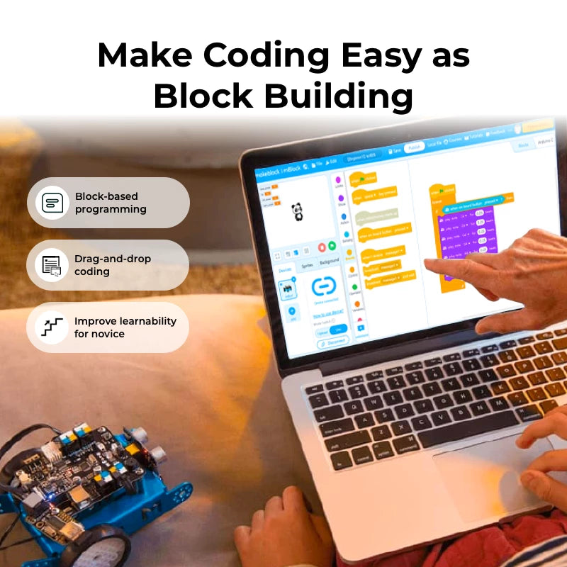

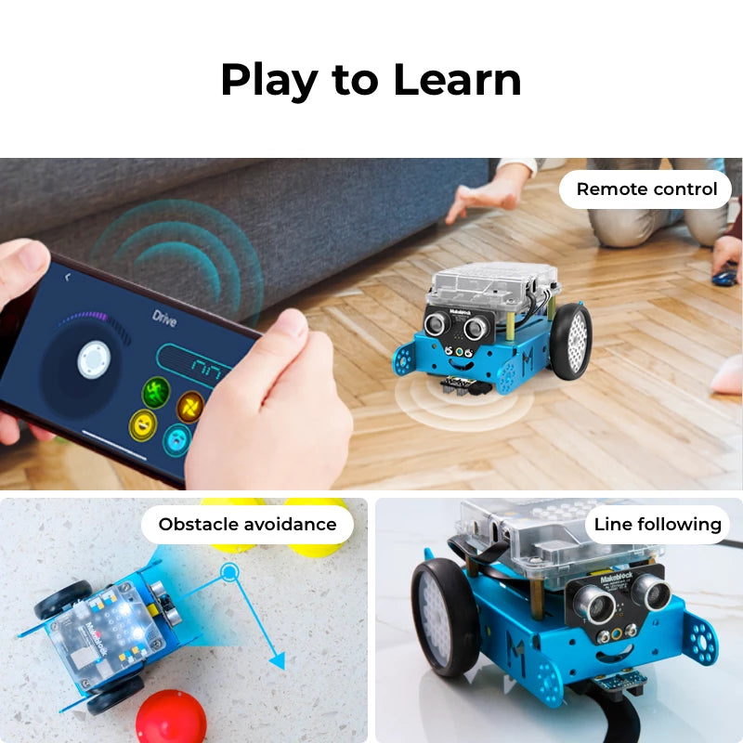

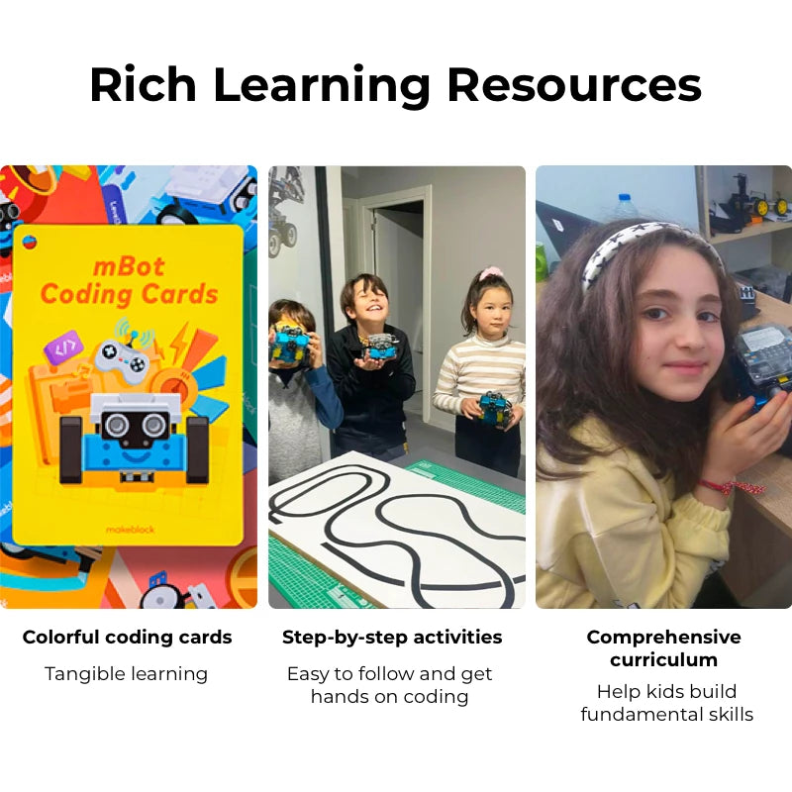

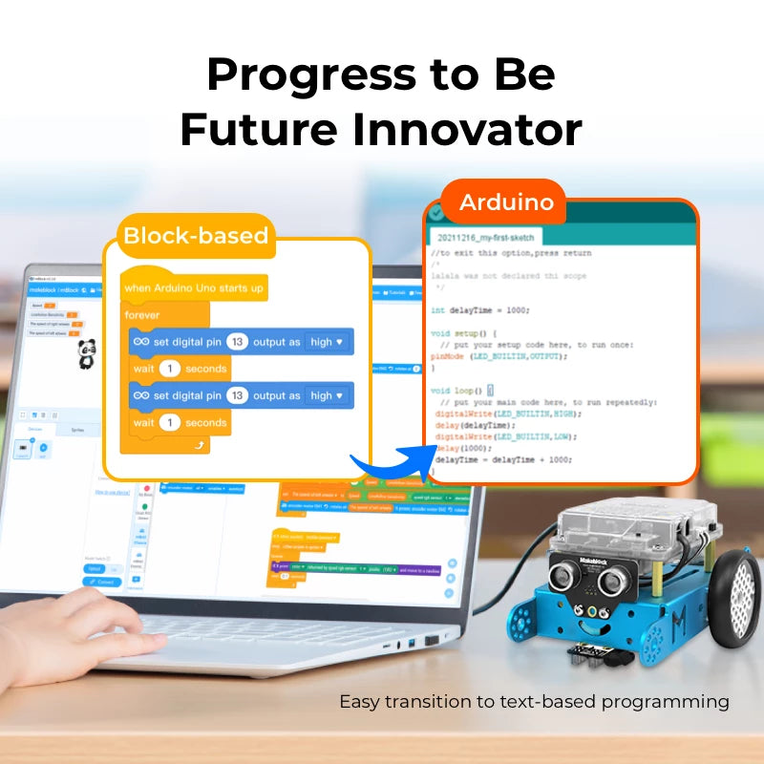

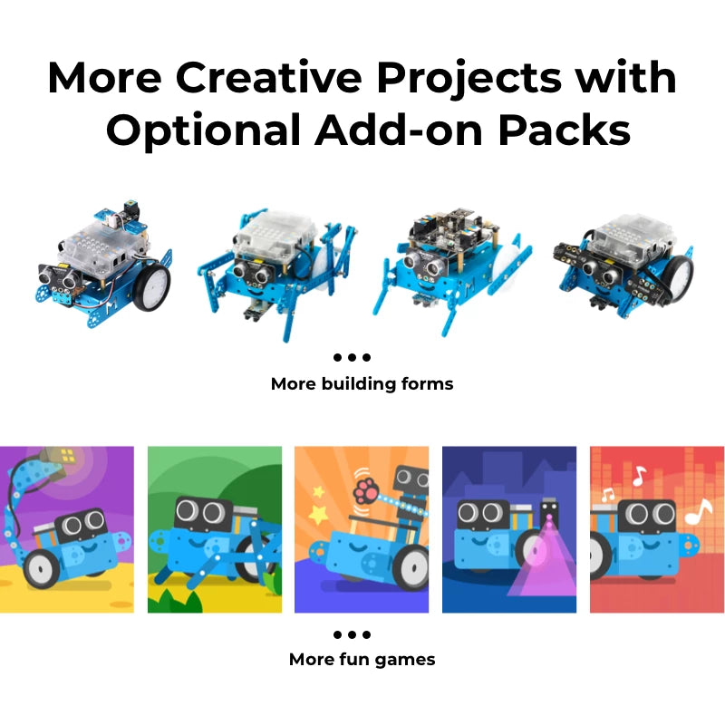

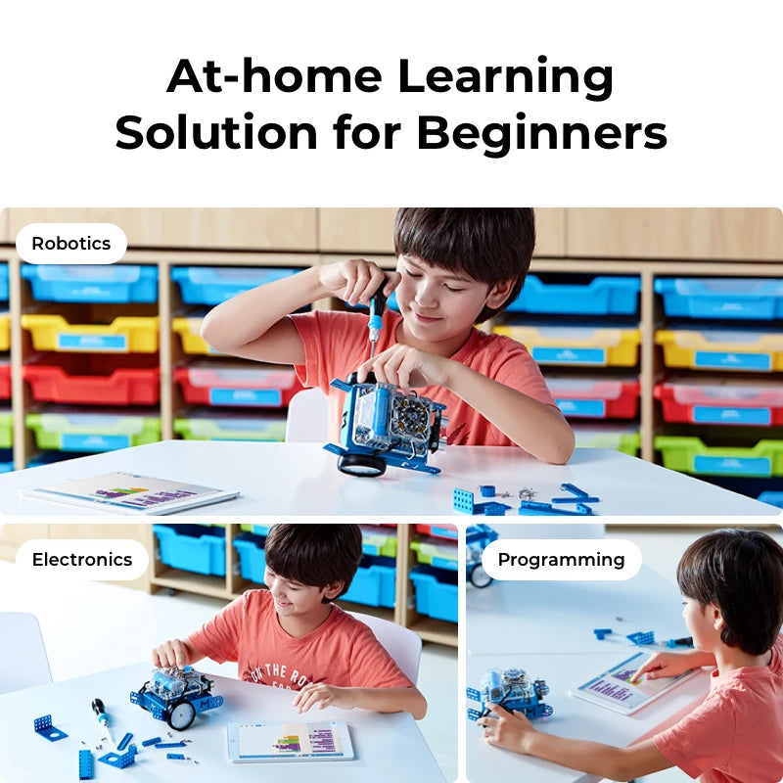

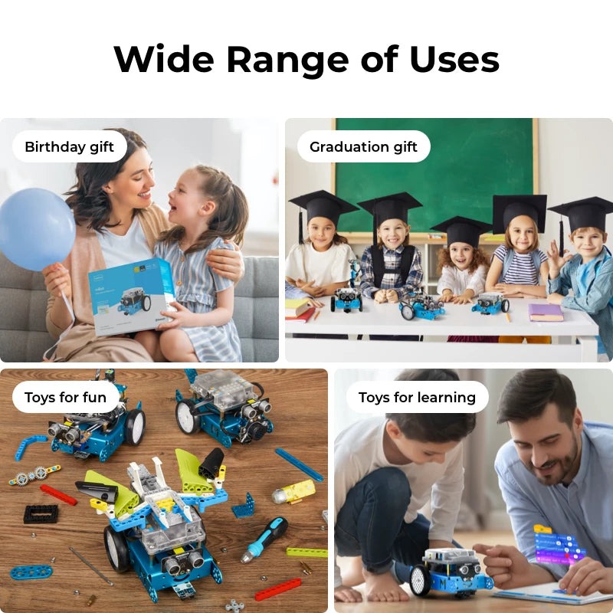

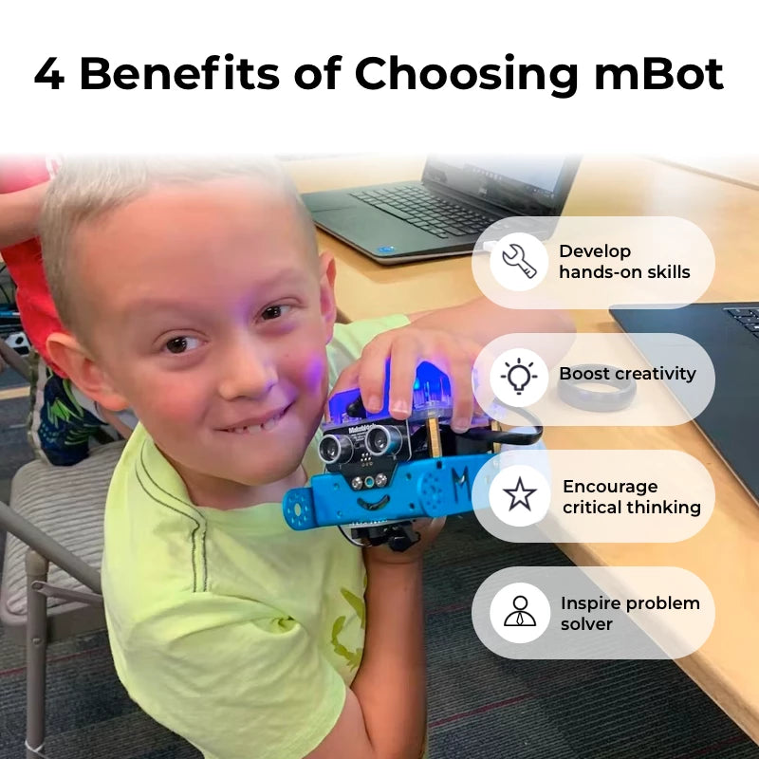

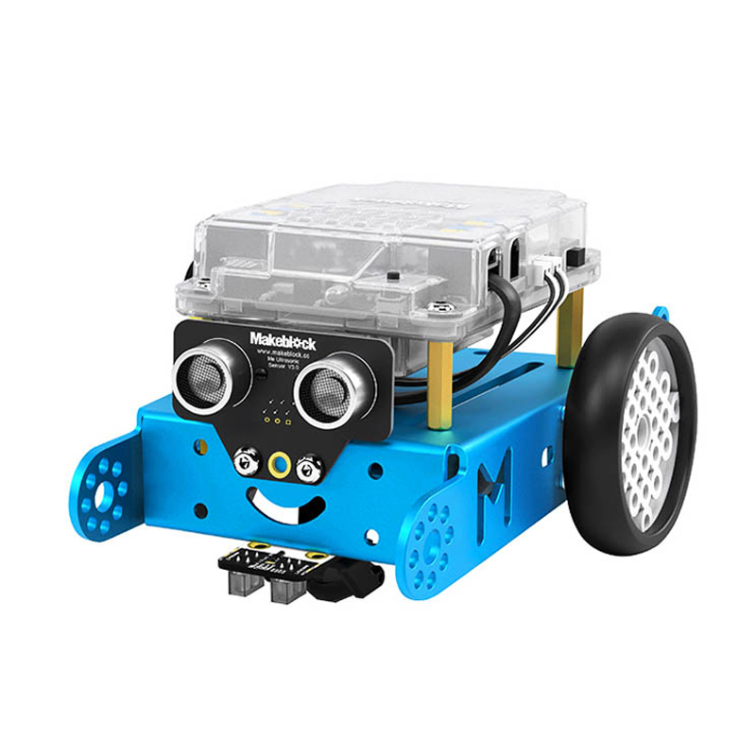

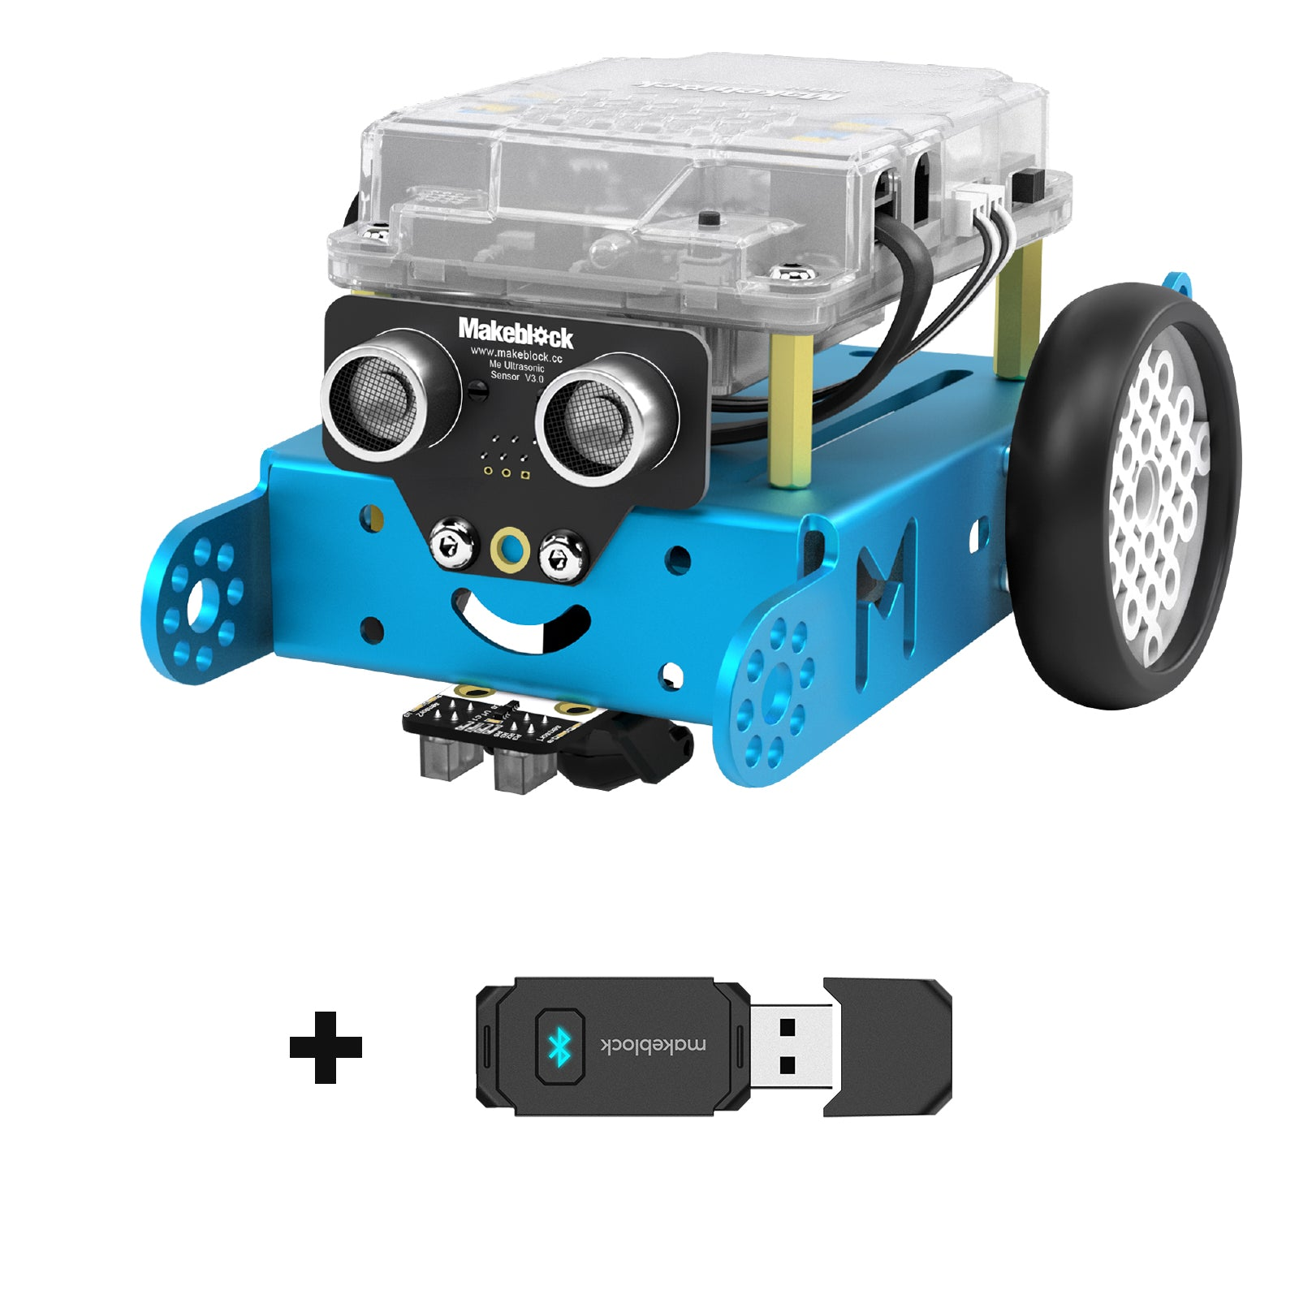

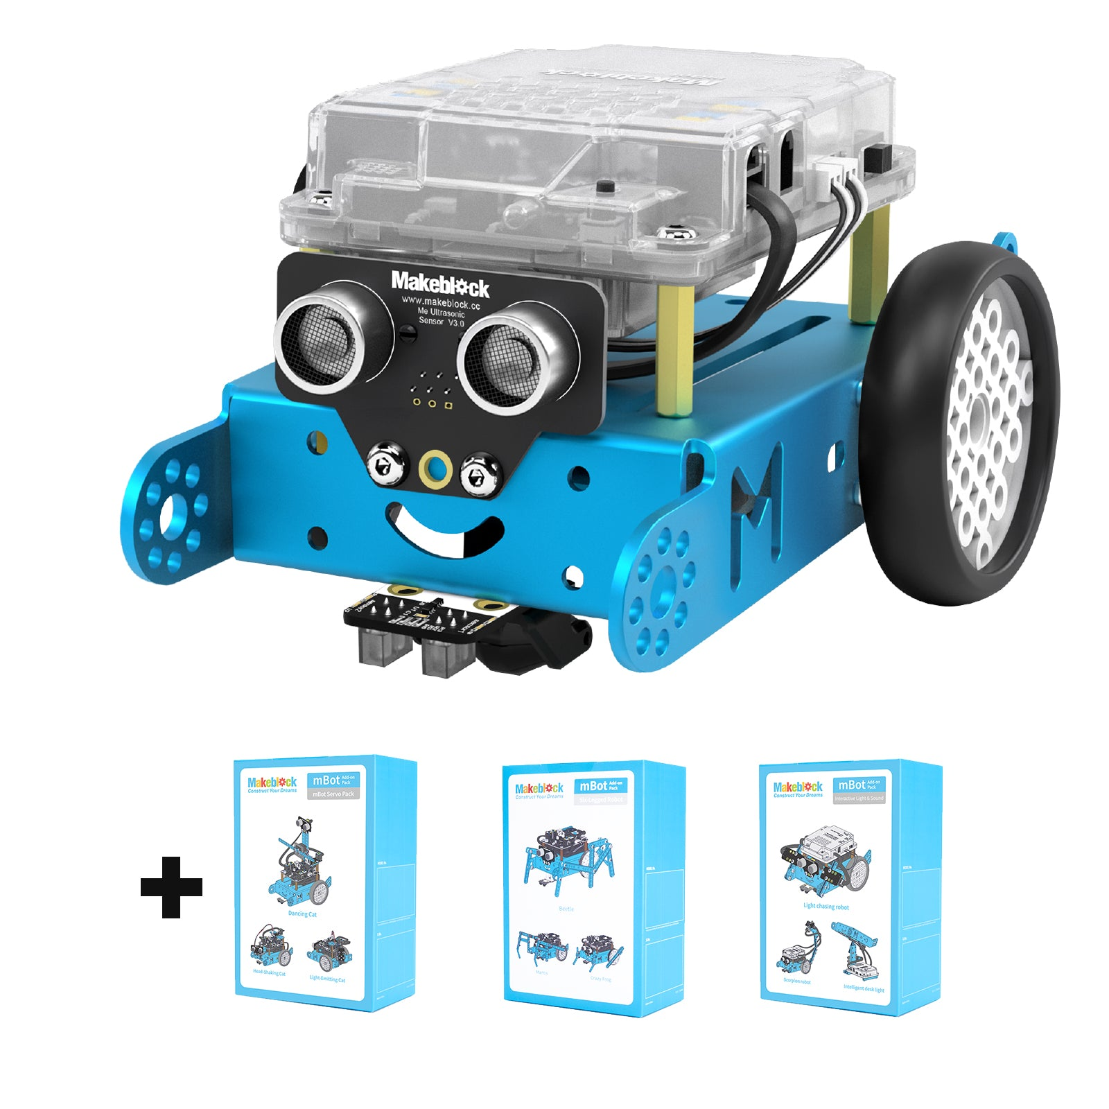

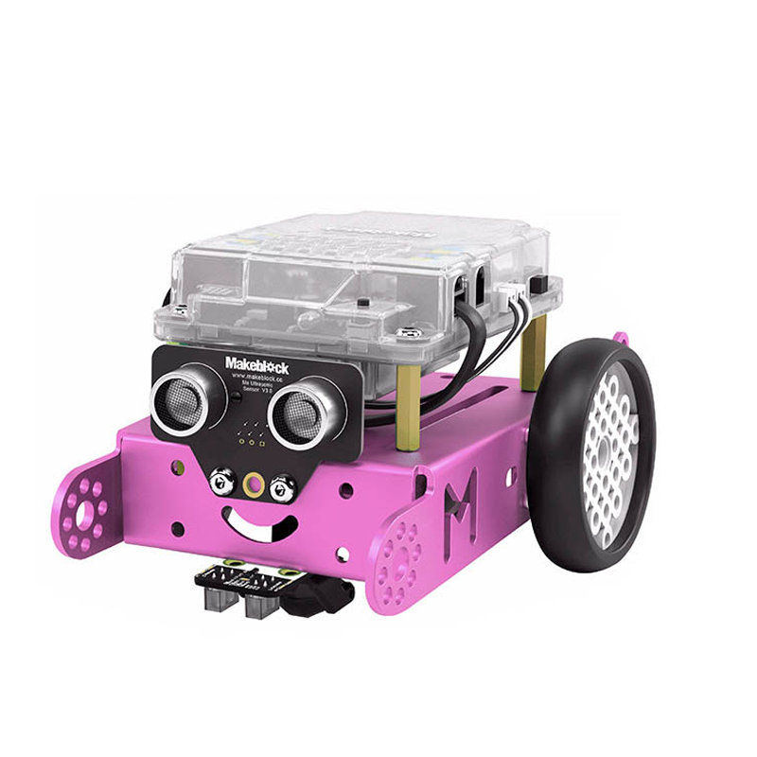

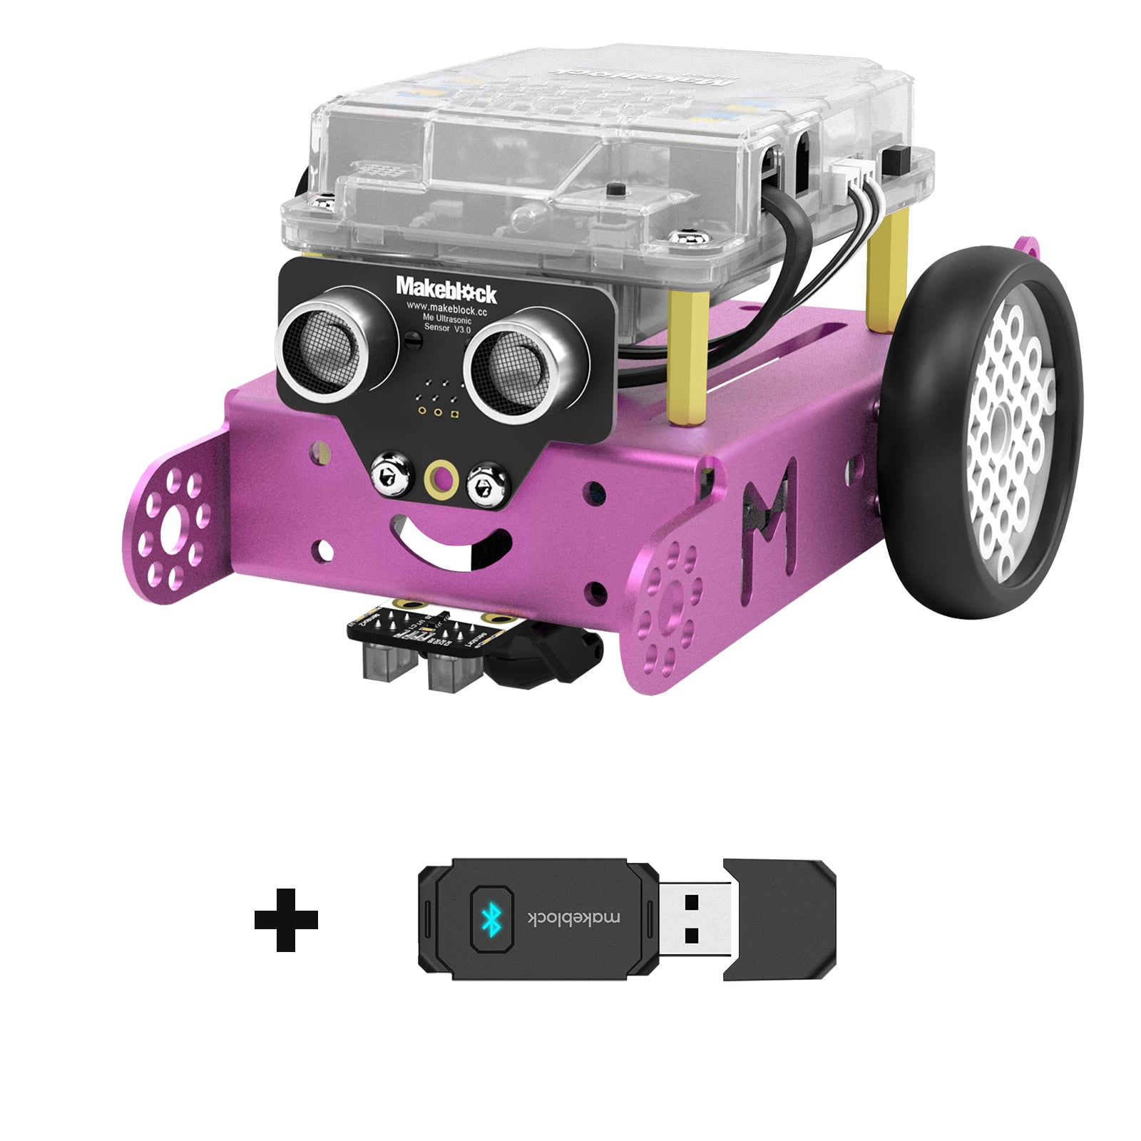

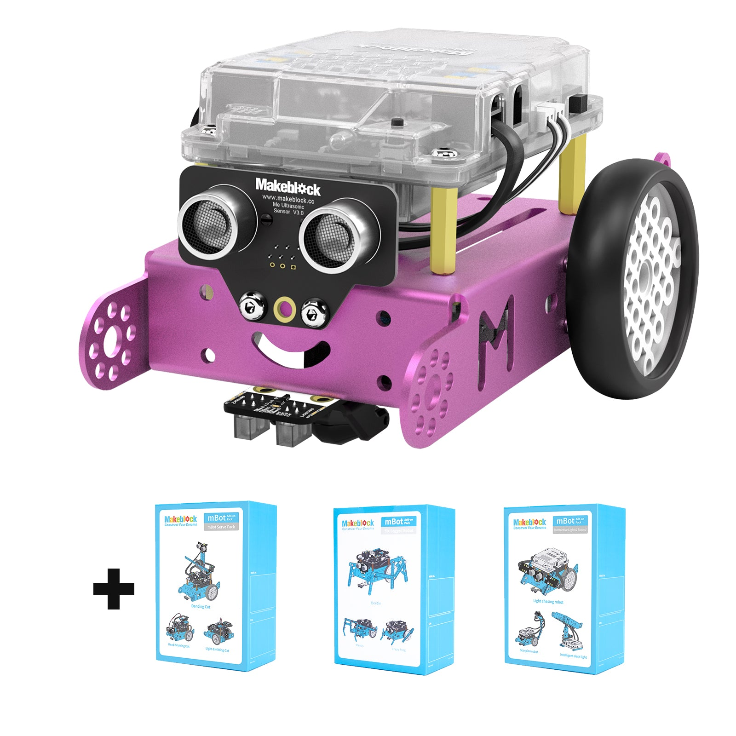

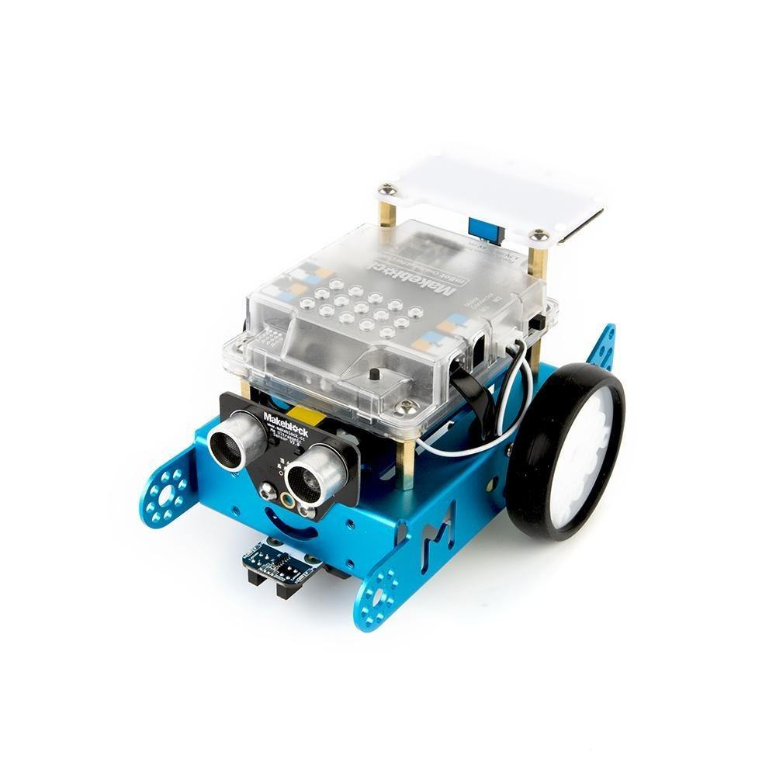

**Makeblock mBot: Kid's First Robot Kit for DIY and STEM Learning**

$74.99

Bottom of Form